**Overview**

Uber Eats is an online food ordering and delivery platform launched by Uber in 2014. Meals are delivered by couriers using cars, scooters, bicycles, or on foot. As of 2021, it operates in more than 45,000 cities. The delivery process is still handled by Uber drivers, who typically only take a few minutes to complete a service. Where Uber Eats is available, Uber will partner with multiple restaurants each day to serve meals to riders.

**Goals**

1. To analyze the geographic coverage of restaurants by selecting the state, city and street where they are located.

2. Analyze the impact of business hours on sales and profits.

3. Analyze the impact of individual product prices, average dish prices and highest (low) dish prices on merchant sales.

4. Analysis of the impact of recent transactions on sales.

5. Analyze the impact of positive feedback, store score and collection rate on sales.

**Data model**

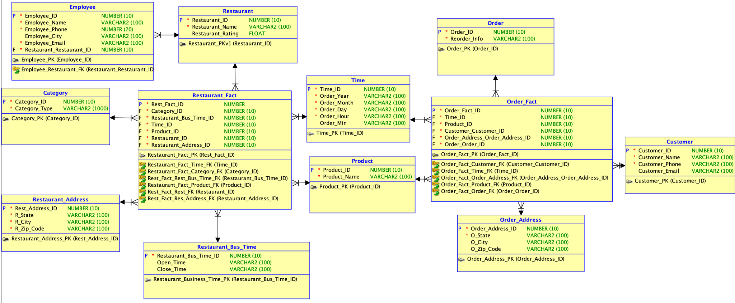

**Map Distribution**

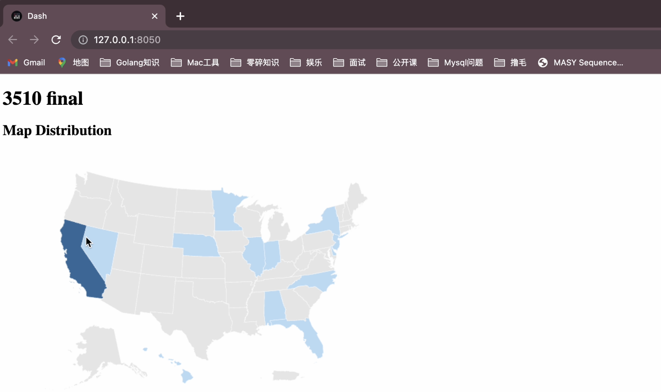

This graph shows us a visual representation of the distribution of restaurants that have partnered with Uber Eats across North America. The shading on the map indicates the concentration of Uber Eats partners, with darker regions indicating a higher number of restaurants that work with the popular food delivery service. California has the most restaurants partnering with Uber Eats.The company should increase the number of restaurants covering the central and northern regions.

**Average Business Hours**

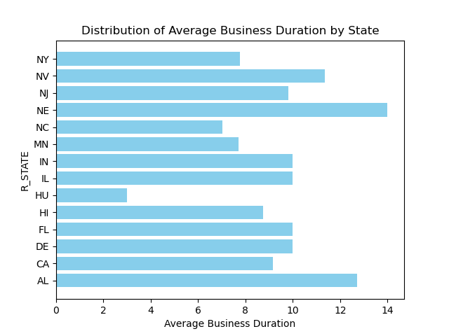

This graph shows the average business duration by state. We can see that NE has the longest business duration and HU has the shortest business duration. According to the data in the graph, restaurants in most areas are open for 10 hours or more. If new restaurants want to stay competitive, they should keep their business hours around 10 hours.

**Average Price**

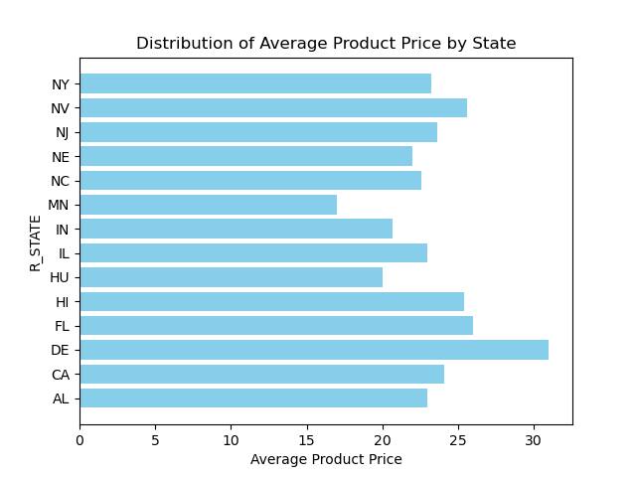

This chart shows the average product price by state. We can see that DE has the highest product price and MN has the lowest product price. On the whole, the avg price is mainly concentrated at 22. To open a restaurant in the east or west, the price should be in the range of 20-25 to be competitive.

**Distribution of Restaurant by State**

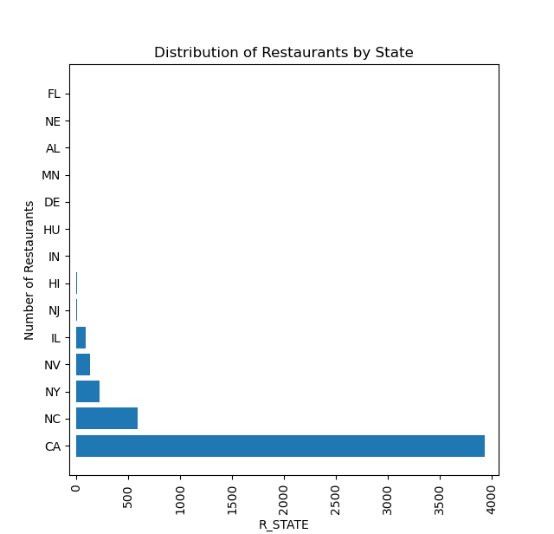

As shown above, we picked the top 5 states with the most restaurants as our further analysis. ( CA, NC, NY, NV, IL) In the later stage of development, Uber Eats should strengthen cooperation with restaurants in the central and northern regions, so as to achieve nationwide coverage of cooperative restaurants.

**Category Type**

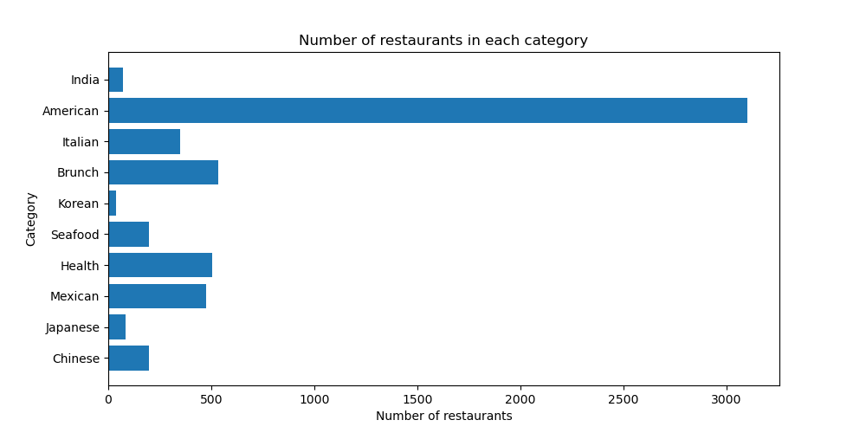

This graph shows the number of restaurants in each category. We can see that American restaurants have the largest number and widest coverage, followed by Brunch restaurants. The least number and least coverage are Korean restaurants.

**Correlation between rating,business_hour and product price**

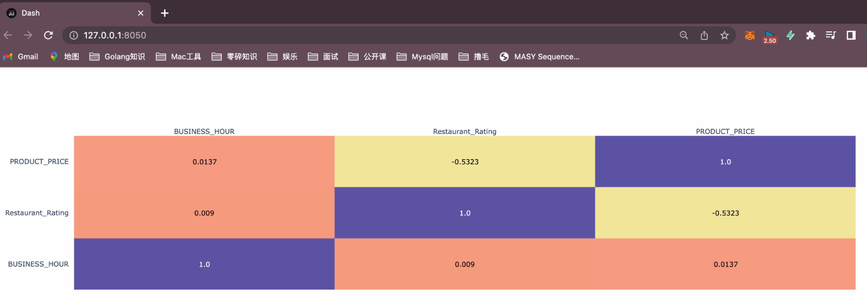

This heat map represents the correlation of the three variables business_hour,restaurant_rating, and product_price.From the graph, we can conclude that the absolute value of the correlation coefficient between business_hour and restaurant_rating, business_hour and product_price is less than 0.3, and the correlation is very weak, and we can almost consider that they are not correlated. product_price and The absolute value of the correlation coefficient between restaurant_rating is 0.5323, when 0.5<|correlation coefficient|<0.8, it means that product_price has a significant linear relationship with restaurant_rating. Since product_price and restaurant_rating are negatively correlated, we can learn that the lower the product_price, the higher the restaurant_rating.

**BOXPLOT ANALYSIS**

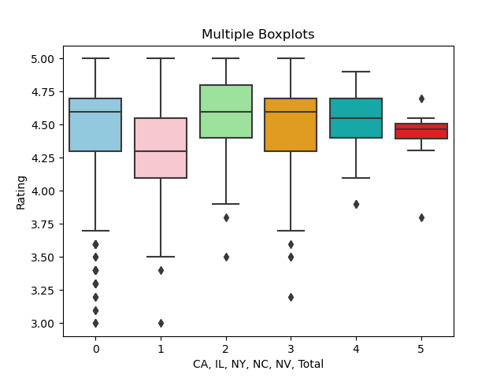

Medians vary widely, with nc and ca having the highest medians. The degree of dispersion varies, where nv, as a high rating top5 state, has a more concentrated rating, compared to il, which has the most discrete data. By looking at the following outliers, it can be seen that ca has the most outliers and has more anomalies. The outliers are concentrated on the side of smaller values, the distribution is left-skewed, and the median is skewed toward the upper quartile, indicating that there is a problem of pulling down the outliers. We used the overall rating as a reference value and selected a median of 4.47 as the criterion for a high rating, we therefore conjectured that location was correlated with rating and therefore performed a follow-up.

**Anova Table**

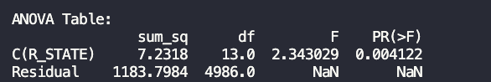

The F of the ANOVA table and the factor position can be obtained by the program as 2.343029. The pr(>f) in the ANOVA table shows that the p-value is 0.004122. From the anova analysis, it is known that the p-value obtained is less than 0.05, which means that the effect of the factor position is significant. If it is less than 0.01, it means that the effect of factor position is highly significant. Based on the p-value obtained, it is known that state is highly significant than restaurant rating.

This analysis can prove that restaurant location is related to high ratings, so if uber eats wants to improve customer satisfaction, then it should deploy restaurants in developed areas.

**Correlation between rating, business_hour and product price**

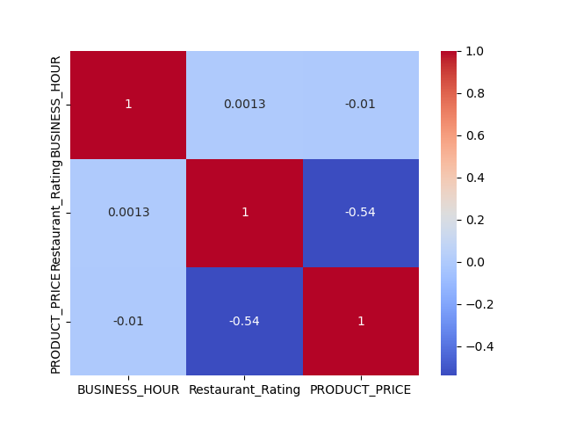

This graph is the correlation graph. The absolute value of the correlation coefficient between product_price and restaurant rating can be found in the picture is 0.54, when 0.5<|correlation coefficient|<0.8, it means that product_price has a significant linear relationship with restaurant rating. According to the negative correlation, we can conclude that the lower the price, the higher the rating.

Therefore, to get high satisfaction, you can reduce the product price appropriately.

**REORDER_RATE**

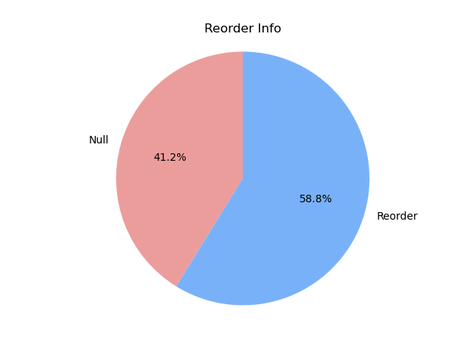

This graph shows the reorder information. This graph shows what percentage of people are willing to order again with Uber Eats. We can see that 58.8% of people like to reorder with Uber Eats. Although the proportion of reorders is relatively high, the company should strengthen customer relationship management, maintain close contact with customers, understand their needs and feedback, solve problems in a timely manner, and improve customer satisfaction in the future development.

**Dashboard code:**

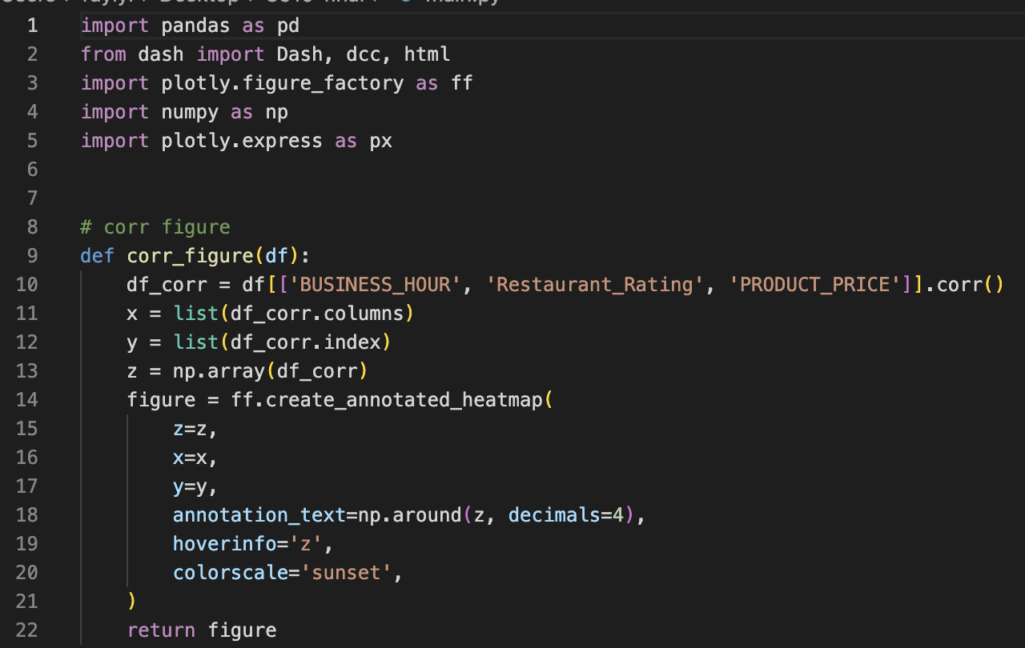

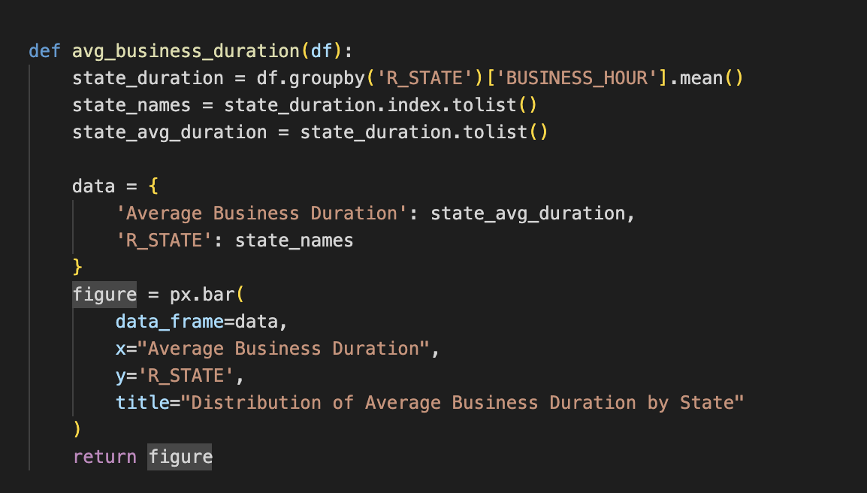

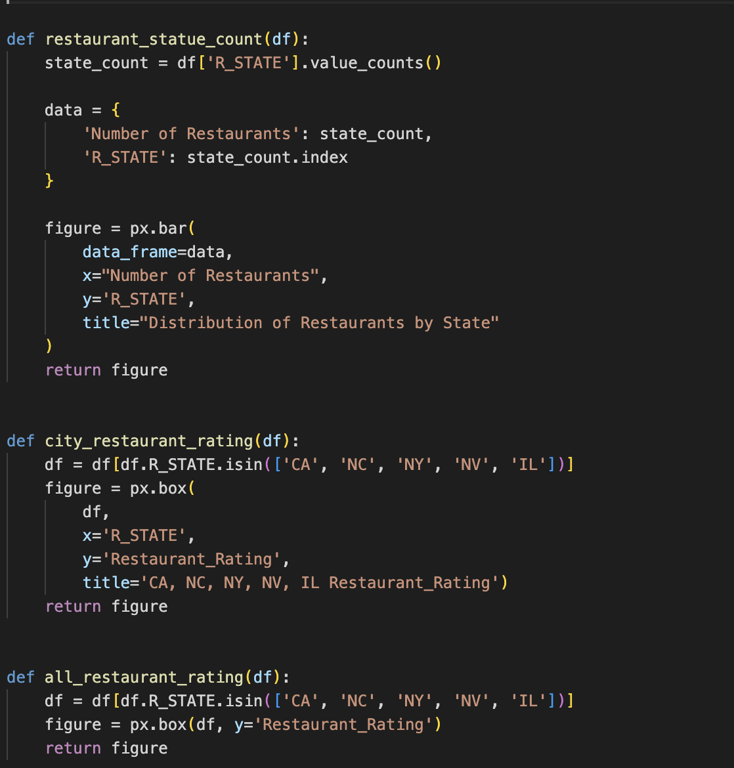

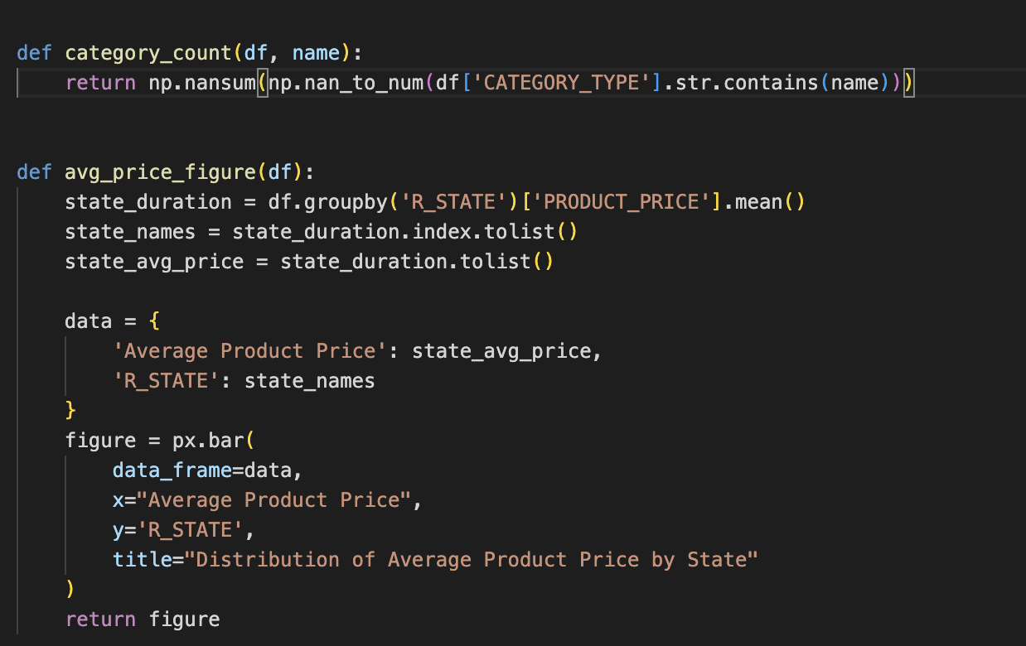

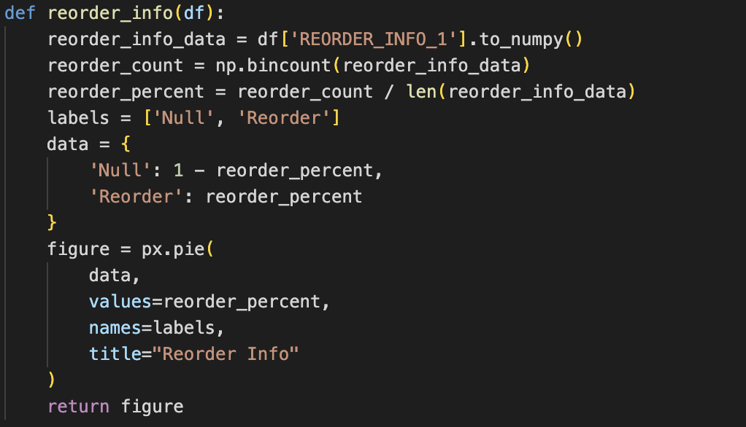

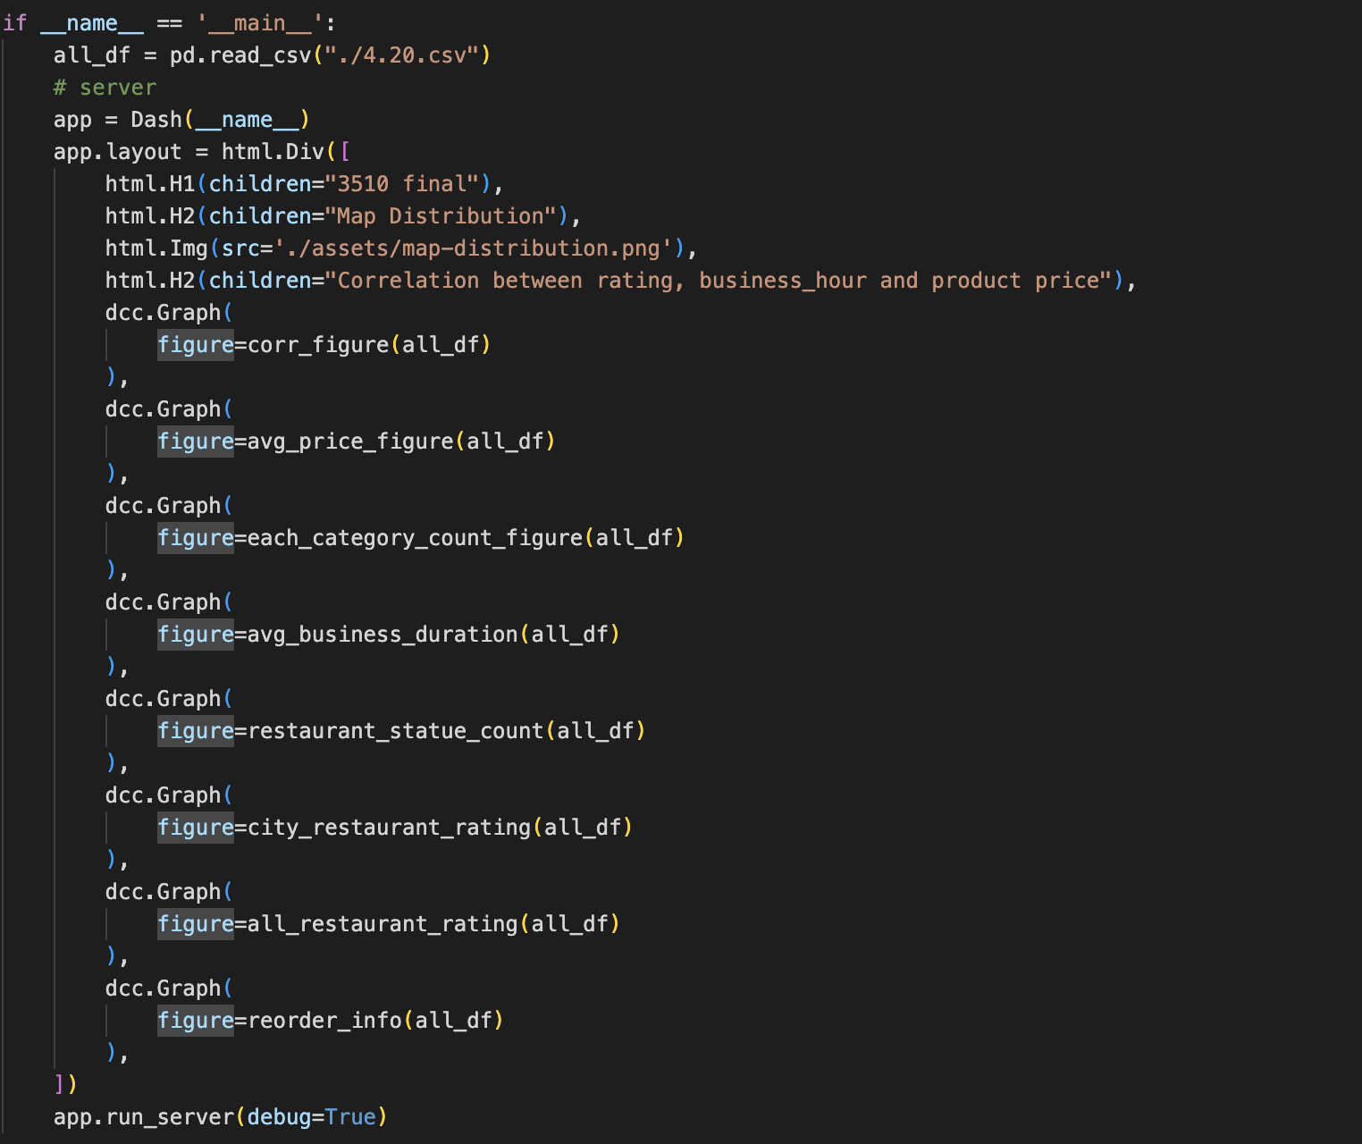

Analysis Code：

import pandas as pd

import matplotlib.pyplot as plt

df = pd.read_csv('4.20.csv')

# 所有的州的avg

avg_by_state = round(df.groupby('R_STATE')['Restaurant_Rating'].mean(),1)

sorted_df = avg_by_state.sort_values(*ascending*=False)

print(sorted_df)

#top 5 ：MN, NY, CA, NC, HV

# # ## 证明大于95%的概率可以说明 高评分与地区有关系 证明到底评分的分类正确

from statsmodels.formula.api import ols

from statsmodels.stats.anova import anova_lm

grouped = df.groupby('R_STATE')

means = grouped['boo'].mean()

# ANOVA检验

import statsmodels.api as sm

from statsmodels.formula.api import ols

from statsmodels.stats.anova import anova_lm

formula = 'boo ~ C(R_STATE)'

model = ols(formula, *data*=df).fit()

aov_table = anova_lm(model, *typ*=2)

print('Means:')

print(means)

print('')

print('ANOVA Table:')

print(aov_table)

#相关系数corr

import seaborn as sns

import matplotlib.pyplot as plt

corr = df[['BUSINESS_HOUR', 'Restaurant_Rating', 'PRODUCT_PRICE']].corr()

sns.heatmap(corr, *annot*=True, *cmap*='coolwarm')

plt.show()

# 散点图

plt.scatter(df['NY_STATE'], df['Restaurant_Rating'])

plt.title('Restaurant_Rating vs. NY_STATE')

plt.xlabel('NY_STATE')

plt.ylabel('Restaurant_Rating')

plt.show()

import csv

import seaborn as sns

import matplotlib.pyplot as plt

rating1 = []

rating2 = []

rating3 = []

rating4 = []

rating5 = []

rating6 = []

with open('4.20.csv', 'r') as f:

reader = csv.reader(f)

for col in reader:

if col[7] == 'CA':

rating_str = col[2]

if rating_str != '':

rating1.append(float(rating_str))

elif col[7] == 'IL':

rating_str = col[2]

if rating_str != '':

rating2.append(float(rating_str))

elif col[7] == 'NY':

rating_str = col[2]

if rating_str != '':

rating3.append(float(rating_str))

elif col[7] == 'NC':

rating_str = col[2]

if rating_str != '':

rating4.append(float(rating_str))

elif col[7] == 'NV':

rating_str = col[2]

if rating_str != '':

rating5.append(float(rating_str))

grouped = df.groupby('R_STATE')['Restaurant_Rating'].mean()

# total

fig, ax = plt.subplots()

sns.boxplot(*data*=[rating1, rating2, rating3, rating4, rating5, rating6], *ax*=ax, *palette*=['skyblue', 'pink', 'lightgreen', 'orange', 'c','r'])

ax.set(*title*='Multiple Boxplots', *xlabel*='CA, IL, NY, NC, NV',*ylabel*='Rating')

plt.show()

import pandas as pd

import seaborn as sns

import matplotlib.pyplot as plt

data = pd.read_csv('4.20.csv')

grouped = data.groupby('R_STATE')['Restaurant_Rating'].mean()

fig, ax = plt.subplots()

sns.boxplot(*data*=[data[data['R_STATE'] == 'CA']['Restaurant_Rating'].dropna(),

data[data['R_STATE'] == 'IL']['Restaurant_Rating'].dropna(),

data[data['R_STATE'] == 'NY']['Restaurant_Rating'].dropna(),

data[data['R_STATE'] == 'NC']['Restaurant_Rating'].dropna(),

data[data['R_STATE'] == 'NV']['Restaurant_Rating'].dropna(),

grouped.values],

*ax*=ax,

*palette*=['skyblue', 'pink', 'lightgreen', 'orange', 'c', 'r'])

ax.set(*title*='Multiple Boxplots', *xlabel*='CA, IL, NY, NC, NV, Total', *ylabel*='Rating')

plt.show()

# COUNT CATEGORY

import numpy as np

chinese = np.nansum(np.nan_to_num(df['CATEGORY_TYPE'].str.contains('Chinese')))

japanese = np.nansum(np.nan_to_num(df['CATEGORY_TYPE'].str.contains('Japanese')))

mexican = np.nansum(np.nan_to_num(df['CATEGORY_TYPE'].str.contains('Mexican')))

health = np.nansum(np.nan_to_num(df['CATEGORY_TYPE'].str.contains('Health')))

seafood = np.nansum(np.nan_to_num(df['CATEGORY_TYPE'].str.contains('Seafood')))

korean = np.nansum(np.nan_to_num(df['CATEGORY_TYPE'].str.contains('Korean')))

brunch = np.nansum(np.nan_to_num(df['CATEGORY_TYPE'].str.contains('Brunch')))

italian = np.nansum(np.nan_to_num(df['CATEGORY_TYPE'].str.contains('Italian')))

american = np.nansum(np.nan_to_num(df['CATEGORY_TYPE'].str.contains('American')))

india = np.nansum(np.nan_to_num(df['CATEGORY_TYPE'].str.contains('India')))

print(f"chinese: {chinese}")

print(f"japanese: {japanese}")

print(f"mexican: {mexican}")

print(f"health: {health}")

print(f"seafood: {seafood}")

print(f"korean: {korean}")

print(f"brunch: {brunch}")

print(f"italian: {italian}")

print(f"american: {american}")

print(f"india: {india}")

import matplotlib.pyplot as plt

counts = [chinese, japanese, mexican, health, seafood, korean, brunch, italian, american, india]

categories = ['Chinese', 'Japanese', 'Mexican', 'Health', 'Seafood', 'Korean', 'Brunch', 'Italian', 'American', 'India']

fig, ax = plt.subplots(*figsize*=(10,5))

ax.barh(categories, counts)

ax.set_xlabel('Number of restaurants')

ax.set_ylabel('Category')

ax.set_title('Number of restaurants in each category')

plt.show()

# reorder info rate

import numpy as np

import matplotlib.pyplot as plt

reorder_info = df['REORDER_INFO_1'].to_numpy()

reorder_count = np.bincount(reorder_info)

reorder_percent = reorder_count / len(reorder_info)

labels = ['Null', 'Reorder']

colors = ['#ff9999', '#66b3ff']

fig1, ax1 = plt.subplots()

ax1.pie(reorder_percent, *colors*=colors, *labels*=labels, *autopct*='%1.1f%%', *startangle*=90)

ax1.axis('equal')

plt.title('Reorder Info')

plt.show()

#不同州business的直方图：

import matplotlib.pyplot as plt

state_duration = df.groupby('R_STATE')['BUSINESS_HOUR'].mean()

state_names = state_duration.index.tolist()

state_avg_duration = state_duration.tolist()

plt.barh(state_names, state_avg_duration, *color*='skyblue')

plt.xlabel('Average Business Duration')

plt.ylabel('R_STATE')

plt.title('Distribution of Average Business Duration by State')

plt.show()

不同州的avg price

import matplotlib.pyplot as plt

state_duration = df.groupby('R_STATE')['PRODUCT_PRICE'].mean()

state_names = state_duration.index.tolist()

state_avg_duration = state_duration.tolist()

plt.barh(state_names, state_avg_duration, *color*='skyblue')

plt.xlabel('Average Product Price')

plt.ylabel('R_STATE')

plt.title('Distribution of Average Product Price by State')

plt.show()

# COUNT STATE

import matplotlib.pyplot as plt

state_count = df['R_STATE'].value_counts()

plt.barh(state_count.index, state_count.values)

plt.xlabel('R_STATE')

plt.ylabel('Number of Restaurants')

plt.title('Distribution of Restaurants by State')

plt.xticks(*rotation*=90)

plt.show()

Model：

-- Generated by Oracle SQL Developer Data Modeler 22.2.0.165.1149

-- at: 2023-04-10 01:27:30 EDT

-- site: Oracle Database 11g

-- type: Oracle Database 11g

-- predefined type, no DDL - MDSYS.SDO_GEOMETRY

-- predefined type, no DDL - XMLTYPE

CREATE TABLE category (

category_id NUMBER(8) NOT NULL,

category_type VARCHAR2(20)

);

ALTER TABLE category ADD CONSTRAINT category_pk PRIMARY KEY ( category_id );

CREATE TABLE customer (

customer_id NUMBER(8) NOT NULL,

customer_name VARCHAR2(20) NOT NULL,

customer_phone NUMBER(10) NOT NULL,

customer_email VARCHAR2(20) NOT NULL

);

ALTER TABLE customer ADD CONSTRAINT customer_pk PRIMARY KEY ( customer_id );

CREATE TABLE employee (

employee_id NUMBER(4) NOT NULL,

employee_name VARCHAR2(30) NOT NULL,

employee_phone NUMBER(10) NOT NULL,

employee_address VARCHAR2(50),

employee_email VARCHAR2(30),

restaurant_restaurant_id NUMBER(8)

);

ALTER TABLE employee ADD CONSTRAINT employee_pk PRIMARY KEY ( employee_id );

CREATE TABLE "Order" (

order_id NUMBER(8) NOT NULL,

reorder_info VARCHAR2(20)

);

ALTER TABLE "Order" ADD CONSTRAINT order_pk PRIMARY KEY ( order_id );

CREATE TABLE order_address (

order_address_id NUMBER(8) NOT NULL,

o_state VARCHAR2(20) NOT NULL,

o_city VARCHAR2(20),

o_zip_code VARCHAR2(20)

);

ALTER TABLE order_address ADD CONSTRAINT order_address_pk PRIMARY KEY ( order_address_id );

CREATE TABLE order_fact (

order_fact_id NUMBER(8) NOT NULL,

time_id NUMBER(8) NOT NULL,

product_id NUMBER(8) NOT NULL,

order_order_id NUMBER(8) NOT NULL,

customer_customer_id NUMBER(8) NOT NULL,

order_address_order_address_id NUMBER(8) NOT NULL

);

ALTER TABLE order_fact ADD CONSTRAINT order_fact_pk PRIMARY KEY ( order_fact_id );

CREATE TABLE product (

product_id NUMBER(8) NOT NULL,

product_name VARCHAR2(20) NOT NULL

);

ALTER TABLE product ADD CONSTRAINT product_pk PRIMARY KEY ( product_id );

CREATE TABLE restaurant (

restaurant_id NUMBER(8) NOT NULL,

restaurant_name VARCHAR2(30) NOT NULL,

restaurant_rating FLOAT(2) NOT NULL

);

ALTER TABLE restaurant ADD CONSTRAINT restaurant_pk PRIMARY KEY ( restaurant_id );

CREATE TABLE restaurant_business_time (

restaurant_business_time_id NUMBER(8) NOT NULL,

open_time VARCHAR2(10) NOT NULL,

close_time VARCHAR2(10) NOT NULL

);

ALTER TABLE restaurant_business_time ADD CONSTRAINT restaurant_business_time_pk PRIMARY KEY ( restaurant_business_time_id );

CREATE TABLE resturant_address (

rest_address_id NUMBER(8) NOT NULL,

o_state VARCHAR2(20) NOT NULL,

o_city VARCHAR2(20),

o_zip_code NUMBER(5)

);

ALTER TABLE resturant_address ADD CONSTRAINT resturant_address_pk PRIMARY KEY ( rest_address_id );

CREATE TABLE resturant_fact (

rest_fact_id NUMBER(8) NOT NULL,

category_id NUMBER(8) NOT NULL,

resturant_address_id NUMBER(8) NOT NULL,

restaurant_bus_time_id NUMBER(8) NOT NULL,

time_id NUMBER(8) NOT NULL,

product_id NUMBER(8) NOT NULL,

restaurant_id NUMBER(8) NOT NULL

);

ALTER TABLE resturant_fact ADD CONSTRAINT resturant_fact_pk PRIMARY KEY ( rest_fact_id );

CREATE TABLE time (

time_id NUMBER(8) NOT NULL,

oder_year VARCHAR2(10) NOT NULL,

order_month VARCHAR2(10) NOT NULL,

order_day VARCHAR2(6) NOT NULL,

order_hour NUMBER(2) NOT NULL,

order_min NUMBER(2)

);

ALTER TABLE time ADD CONSTRAINT time_pk PRIMARY KEY ( time_id );

ALTER TABLE employee

ADD CONSTRAINT employee_restaurant_fk FOREIGN KEY ( restaurant_restaurant_id )

REFERENCES restaurant ( restaurant_id );

ALTER TABLE order_fact

ADD CONSTRAINT order_fact_customer_fk FOREIGN KEY ( customer_customer_id )

REFERENCES customer ( customer_id );

ALTER TABLE order_fact

ADD CONSTRAINT order_fact_order_address_fk FOREIGN KEY ( order_address_order_address_id )

REFERENCES order_address ( order_address_id );

ALTER TABLE order_fact

ADD CONSTRAINT order_fact_order_fk FOREIGN KEY ( order_order_id )

REFERENCES "Order" ( order_id );

ALTER TABLE order_fact

ADD CONSTRAINT order_fact_product_fk FOREIGN KEY ( product_id )

REFERENCES product ( product_id );

ALTER TABLE order_fact

ADD CONSTRAINT order_fact_time_fk FOREIGN KEY ( time_id )

REFERENCES time ( time_id );

ALTER TABLE resturant_fact

ADD CONSTRAINT rest_fact_rest_address_fk FOREIGN KEY ( resturant_address_id )

REFERENCES resturant_address ( rest_address_id );

ALTER TABLE resturant_fact

ADD CONSTRAINT resturant_fact_category_fk FOREIGN KEY ( category_id )

REFERENCES category ( category_id );

ALTER TABLE resturant_fact

ADD CONSTRAINT resturant_fact_fk FOREIGN KEY ( restaurant_id )

REFERENCES restaurant ( restaurant_id );

ALTER TABLE resturant_fact

ADD CONSTRAINT resturant_fact_product_fk FOREIGN KEY ( product_id )

REFERENCES product ( product_id );

ALTER TABLE resturant_fact

ADD CONSTRAINT resturant_fact_time_fk FOREIGN KEY ( time_id )

REFERENCES time ( time_id );

ALTER TABLE resturant_fact

ADD CONSTRAINT resturant_fact_time_fkv1 FOREIGN KEY ( restaurant_bus_time_id )

REFERENCES restaurant_business_time ( restaurant_business_time_id );

-- Oracle SQL Developer Data Modeler Summary Report:

--

-- CREATE TABLE 12

-- CREATE INDEX 0

-- ALTER TABLE 24

-- CREATE VIEW 0

-- ALTER VIEW 0

-- CREATE PACKAGE 0

-- CREATE PACKAGE BODY 0

-- CREATE PROCEDURE 0

-- CREATE FUNCTION 0

-- CREATE TRIGGER 0

-- ALTER TRIGGER 0

-- CREATE COLLECTION TYPE 0

-- CREATE STRUCTURED TYPE 0

-- CREATE STRUCTURED TYPE BODY 0

-- CREATE CLUSTER 0

-- CREATE CONTEXT 0

-- CREATE DATABASE 0

-- CREATE DIMENSION 0

-- CREATE DIRECTORY 0

-- CREATE DISK GROUP 0

-- CREATE ROLE 0

-- CREATE ROLLBACK SEGMENT 0

-- CREATE SEQUENCE 0

-- CREATE MATERIALIZED VIEW 0

-- CREATE MATERIALIZED VIEW LOG 0

-- CREATE SYNONYM 0

-- CREATE TABLESPACE 0

-- CREATE USER 0

--

-- DROP TABLESPACE 0

-- DROP DATABASE 0

--

-- REDACTION POLICY 0

--

-- ORDS DROP SCHEMA 0

-- ORDS ENABLE SCHEMA 0

-- ORDS ENABLE OBJECT 0

--

-- ERRORS 0

-- WARNINGS 0